

**Functional Specs/Product Requirement Document**



Creating a Functional Specs/Product Requirement Document for the "CollegeConnect" App.

** User Types/Personas:**

1. **Student Users:**

* Regular students seeking academic assistance.
* Students offering help to peers.

1. **Faculty Users:**

* Professors and academic staff providing guidance and answering queries.

1. **Guest Faculty Users:**

* Subject matter experts from the city, contributing to academic discussions.

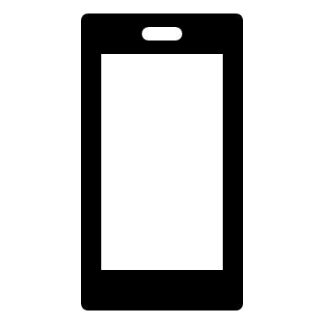 **App Functionalities as User Stories:**

1. **Student Users :**

* As a student, I can post questions or doubts in specific subject categories.
* As a student, I can view and search for doubts and questions relevant to my subjects.
* As a student, I can view profiles of other students and faculty members.

1. **Faculty users:**

* As a faculty member, I can answer student queries and provide academic guidance.
* As a faculty member, I can monitor and moderate the academic discussions.

1. **Guest Faculty Users:**

* As a guest faculty, I can participate in academic discussions and provide expert solutions.

 **Additional Explanations for the Developer:**

* Data schema and database structure.
* Authentication and authorization mechanisms.
* Push notification system for new questions and answers.
* UI/UX guidelines for a seamless user experience.

**Writeup for Times of India:**



*CollegeConnect, the academic-centric social network, has revolutionized how students and faculty interact in educational institutions. Connecting minds and knowledge seamlessly, it fosters a collaborative learning environment. Students can seek assistance from peers and even subject matter experts from the city. Professors actively engage, providing clarity and guidance. The app’s simple and intuitive design ensures a smooth user experience. CollegeConnect is empowering the academic community, bridging gaps, and propelling learning to new heights. A digital nexus for knowledge seekers, making education n not just a process but a vibrant community.*

 **Hand-Drawn Sketches of App Screens:**

